

Carefully fish in the dangerous post-wartime lakes of Brenex (the last place on this land with any food at all) to try and feed your village. Cooperate with your fellow players to find fish and avoid underwater nuclear bombs – and be quick! The more fish you find, the more you can take home to your own family.

**Features**



Fish with your friends in this twist of the classic puzzle game ‘Minesweeper’, where every player fishes on the same board!



Search for fish by clicking on a spot on the Lake



Don’t just pick any random spot to fish: if you find a bomb, it will explode, taking out some of the fish you went through so much trouble to find!



Brenex people are strong and durable: they can survive a single bomb’s radiation with no problem – but cause too many bombs to explode, and the radiation will kill all the fishers



Use the hints left by long-gone fishers to find where bombs are located and avoid them.

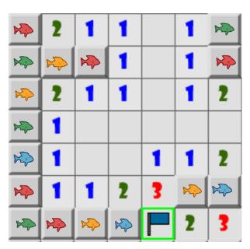

The more fish you catch, the more fish you get to take to both your village and family, and the higher your score will be!

After the final bomb explodes, fishers still have a few minutes to fish until the radiation kills them all.

Every fisher has flags they can place on a fishing spot if they think it hides a bomb. Fishers can see each other’s flags – but careful! They may not always be correctly placed!

Fish enjoy the warmth of radiation: the more bombs there are around a fishing spot, the more fish you will find.

Don’t worry: all the fish you have with you by The End will revert to your village and families – whether you’re dead or alive!



**Overview**

**Design Goals**

* Make a multiplayer version of Minesweeper that is both fun and balanced.
* Comical: design, sound effects, and setting contribute to comedic aspect of the situation.
* PC

**Target Hardware**

* Puzzle-solve as team.
* A twist on an old favorite:
  + What used to be a solitaire game can now be shared between friends and family.

**Unique Selling Points**

* Minesweeper Versus
* Minesweeper (inspiration)

**Competition**

* Players that enjoy parallel play
* Players that enjoy puzzle-solving

**Target Audience**

* Puzzle
* Multiplayer
* Casual

**Genre**

* Fish to feed your village and starving family (PS4’s just aren’t as good as sardines, after the price of fish went up)
* Hone your strategy and problem-solving skills
* Work together with your fellow fishers to bring home a bounty of fish!

**Player Motivation**